

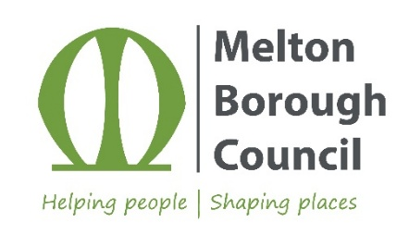

ICT End User Services Engineer
(based at Melton Borough Council offices)

Salary: £33,699 up to £38,220 per annum pro rata
Grade: 6
Location: Melton, Leicestershire
Contract: permanent, 37 hours per week, Monday to Friday

About the role

Do you want to play a pivotal role in enabling two district and borough councils to achieve their digital transformation ambitions?

We are looking to recruit a talented End User Services Engineer who will support our user base to get the best out of the technology we use.

What you will be doing

You will work with internal customers, suppliers and colleagues to deliver the highest-quality ICT Service Desk experience as well as delivering new technologies and ways of working to the organisation.

You will focus on delivering great customer service, excellent solutions as well as proactive maintenance to keep our technology estate in tip-top condition.

The ICT End User Services Engineer works exclusively with all technologies and devices that our customers use; therefore you will need to be able to confidently support the technologies we use:

Desktop – Windows 11, Microsoft365, Teams, SharePoint, Citrix XenApp/XenDesktop

Mobile - Android through our MDM (Intune)

Microsoft Services – Exchange, SQL, SCCM/Microsoft Endpoint Configuration Manager (MECM), WSUS

Active Directory and Windows administration tools

Virtualisation technologies – VMware, Nutanix (Acropolis)

Remote access systems such as TeamViewer

About you
You will be a proactive and technically capable End User Services Engineer who thrives in a busy, multi-site environment.
Strong troubleshooting skills across Microsoft technologies, paired with excellent customer service and communication.
Flexible and reliable, able to work predominantly on-site while supporting hybrid ways of working.

Essential criteria

Full UK driving licence and access to a suitable vehicle to travel between sites.

Occasional hybrid working may be available however there will be an expectation for 4 or more days per week to be office-based in Melton.

Experience of providing 1st and 2nd line IT service desk support within a busy, multi-site environment, working to ITIL principles.

Strong technical troubleshooting skills across Microsoft technologies, including Windows, Active Directory and Microsoft 365.

Find out more

For an informal discussion about this exciting opportunity please call Iqbal Meman, ICT Service Lead on 01455 255753.

Apply with your CV and supporting statement via our online application form at https://jobsandcareers.hinckley-bosworth.gov.uk or for an application pack call 01455 255836 quoting position reference: R321/Melton
Closing date: 7 June 2026 Interview date: Week beginning 15 June 2026
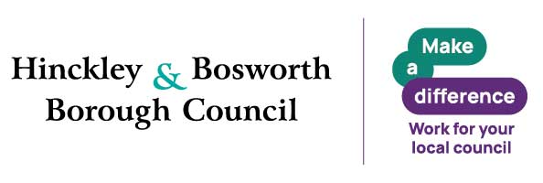
Why Join Hinckley & Bosworth Borough Council
A great place to work, grow and make a real difference. Join a flexible, supportive council offering great development, strong wellbeing, financial benefits and values that put people first.
Make a real difference in Hinckley & Bosworth.
Benefits
- Flexible working – flexi‑time, hybrid, part‑time and compressed hours (role‑dependent)
- Generous annual leave – 26–33 days + bank holidays
- Career development – training, funded qualifications, apprenticeships, e‑learning
- Strong wellbeing support – EAP & counselling, occupational health, wellbeing sessions
- Financial benefits – competitive pay, cost‑of‑living increases, local government pension scheme
- Salary‑sacrifice schemes – tusker cars, tech, cycle to work
- Relocation package up to £5,000
- Lifestyle discounts – retail, travel, entertainment and more
Values and behaviours

We are energetic and passionate, proud of and dedicated to our area.

We strive for excellence. We learn, innovate, challenge, seek out opportunities and embrace new ideas.

We trust, respect and are honest. We listen to each other, to our communities and to our partners and work with them supportively to get things done.

We put the needs of our customers first. We care about being the best we can be and take responsibility for our actions.

Inclusive Employer
We are a Disability Confident and Care Leaver Friendly Employer. Guaranteed interviews are offered to eligible applicants who meet the essential criteria. Reasonable adjustments are available throughout the recruitment process.

Eligibility criteria applies.

